## **Task 1**

**Test Case ID**

* **UI-PT.3**

**Scenario**

* **Purchase pet with invalid or missing Payment details**

**Preconditions**

* Browser is open at <https://petstore.octoperf.com/actions/Catalog.action>
* Signed in as John Smith account, see A1. Account Details Appendix

**Test Steps**

1. Click “Enter the Store” and landed on Store page
2. Select Fish option on the furthest left-hand side
3. Click Fl-FW-02 link for Goldfish
4. Click EST-21 link for Adult Female Goldfish
5. View 5762 Goldfish in stock, click “Add to Cart” button
6. Taken to Shopping Cart page
7. Click “Proceed to Checkout” button
8. Land on Payment Details page and remove data in the Expiry date field and click “Continue” button
9. Land on Confirmation Order page click “Continue” button
10. Land on HTTP Status 500 – Internal Server Error (see A2 Appendix)
11. Click web browser “back” button twice to return to Payment Details page
12. Fill in Expiry Date and leave Card Number field blank (see A3 Appendix)
13. Land on HTTP Status 500 – Internal Server Error (see A4 Appendix)
14. Click web browser “back” button once to return to Payment Details page
15. Fill in incomplete invalid data in Expiry Date and Card Number (see A5 Appendix)
16. Click “Continue” button and taken to order confirmation page with incomplete card data
17. Click on “My Account” button
18. Taken to Account Information Page, Click on “My Orders” button
19. Click on 147586 order ID link and confirm Order Details of incomplete card data is present

**Expected Result**

* The system should **reject** transactions with a **blank** Card Number or Expiry Date.
* The system should **reject** transactions with an **incomplete** Card Number or Expiry Date.

**Actual Result**

* **Blank** Card Number and Expiry Date fields were **rejected**, but returned an **HTTP 500 error log** instead of a user-friendly message.
* **Incomplete** Card Number and Expiry Date fields were **accepted** when they should have been rejected.

**Summary**

The form correctly rejected blank Card Number and Expiry Date fields but failed to reject incomplete entries, making this a high-priority failure due to the security risks associated with payment processing. Error handling also needs improvement, as the only way to navigate back was using the browser’s back button, which risked resubmitting data, as observed in step 16.

**Appendix**

A1. Account Details

### **User Information**

|  |  |
| --- | --- |
| User ID: | John Smith |
| New password: | fake123 |
| Repeat password: | fake123 |

### **Account Information**

|  |  |
| --- | --- |
| First name: | John |
| Last name: | Smith |
| Email: | [Jsmith@gmail.com](mailto:Jsmith@gmail.com) |
| Phone: | 0430558808 |
| Address 1: | Level 8/207 Kent St |
| Address 2: |  |
| City: | Sydney |
| State: | NSW |
| Zip: | 2000 |
| Country: | Australia |

### **Profile Information**

|  |  |
| --- | --- |
| Language Preference: | English |
| Favourite Category: | FISH |
| Enable MyList | [x] |
| Enable MyBanner | [ ] |

A2. HTTP Status 500 – Internal Server Error from missing Expiry Date on in Payment options

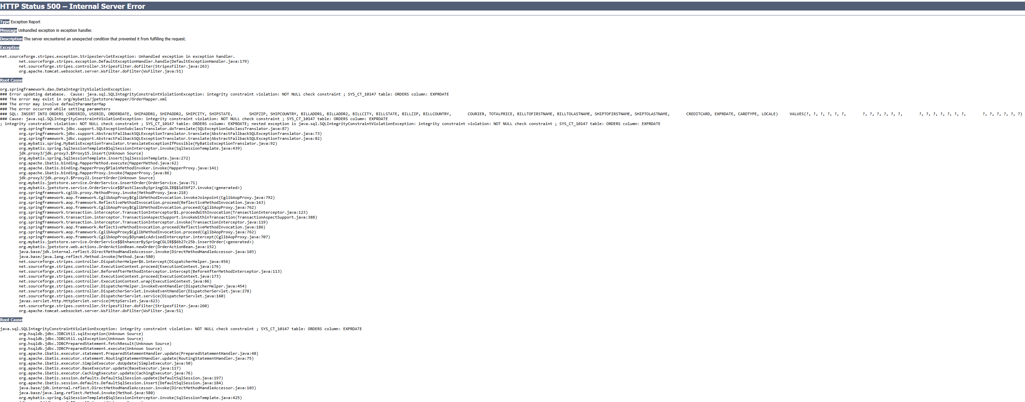

A3. Blank card number

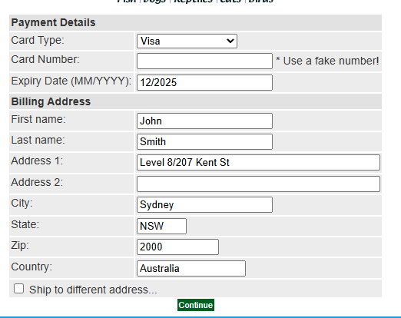

A4. HTTP Status 500 – Internal Server Error from missingCard Number

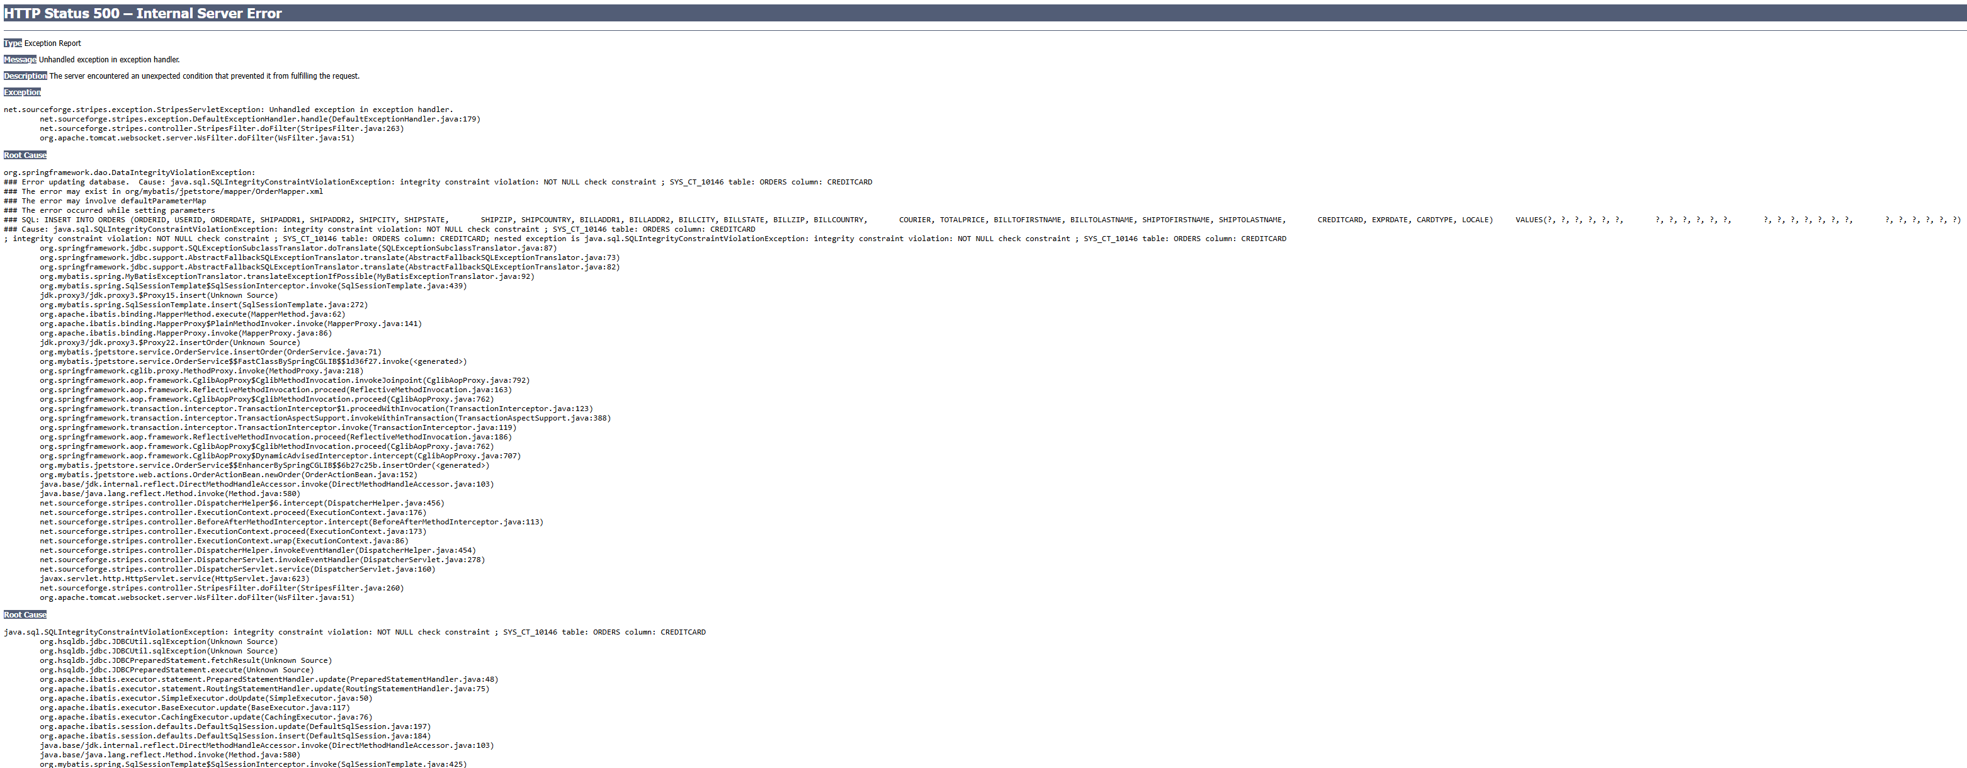

A5. Incomplete Card number and Expiry Date

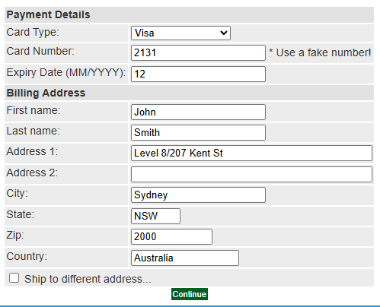

A6. Confirmation page of incomplete Card data

